Marco Antonio Luna Calvillo

A01209537

Email Agent

Intelligent Systems

The emails are a must-use tool nowadays. Everyday millions of emails are sent; a memo from the office to announce a new project, a discount in an item from your wish list in Amazon, the new post from your favorite blog, etc. Even you receive fishing emails that want to steal your information. The emails had made communications easier and more powerful.

The disadvantage of the emails is that is very easy to send one. Emails are the way everybody communicates and is channel to receive information personally, a great step for electronic marketing. Every company, website, enterprise or business send you a lot of emails about updates, promotions, news, between others. Some are very helpful but most of the time the advertising and the social media emails are just too much…

According to Cisco, in August 2019, the average daily legitimate email volume is 72.16 billion while the average daily spam volume is 416.04 billion. Most of emails are spam and we received a lot of them. The number has been increasing for years and it generates more than the 85% of global email traffic.

I bet that if you have more than two social media or subscriptions of any kind linked to your email, most likely you must receive 10 emails per week. Also, if to those you add your work emails, family and friends, spam, etc., you receive a lot of emails every day.

The Agent that I developed is an *EmailAgent*. What it does basically, it classifies your emails depending on the subject and move them to the classification folder. There are three categories for them:

* Social: All emails referring to social media (Facebook, Twitter, Instagram…)
* Publicity: Enterprises that offers discounts, sales and promotions (Amazon, Sears, Banamex…)
* Other: Emails that don’t feed in any classification

The following diagram described how the agent works:

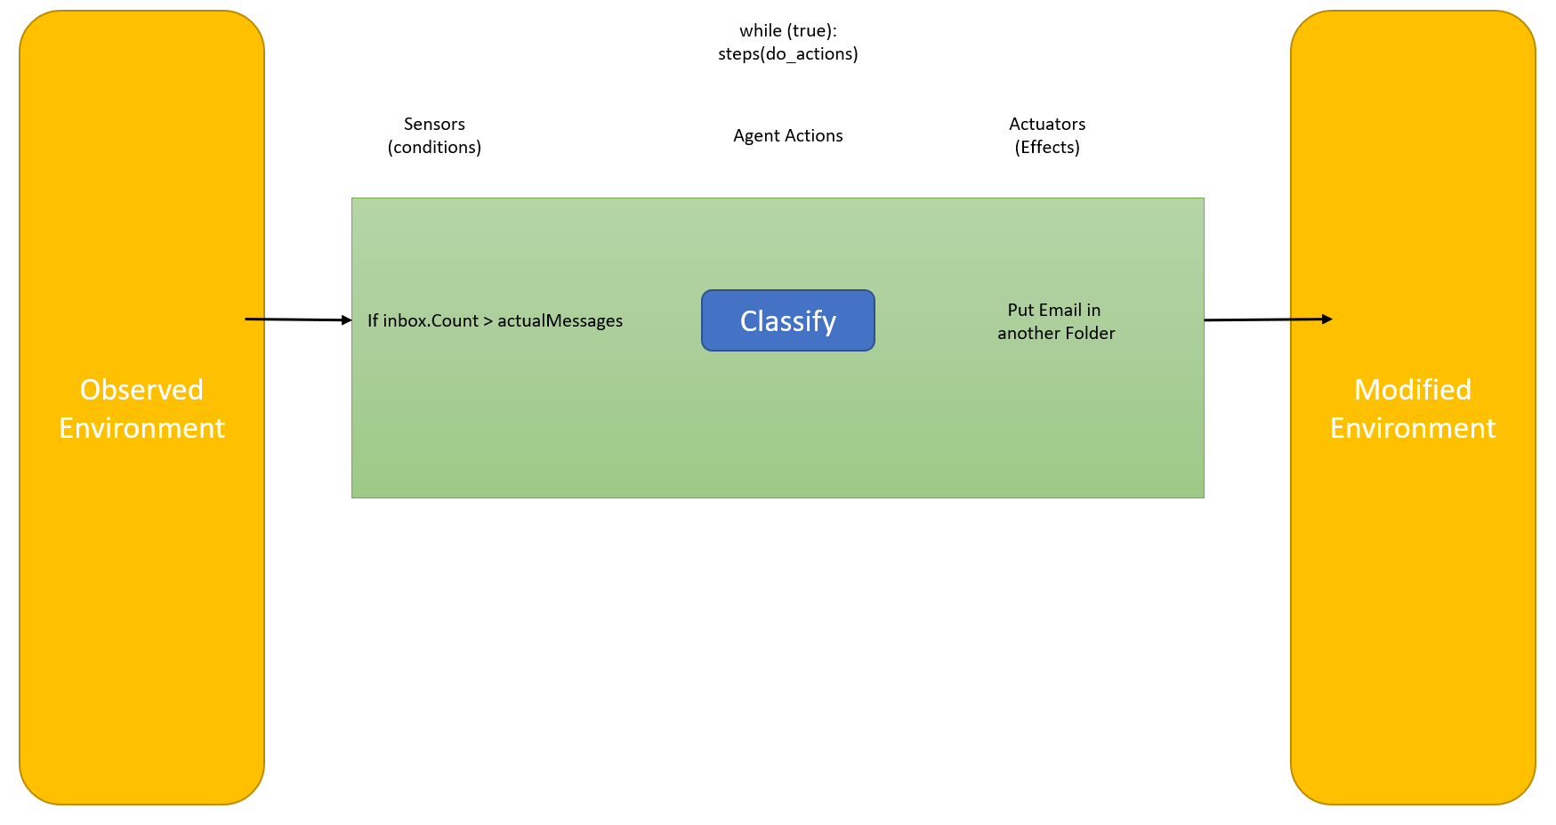

It was developed in C# using Visual Studio (.NET Framework). The primary tool used was *MailKit* that is a NuGet to connect to a mail account (SMTP & IMAP). MailKit is used to check the inbox and to send test emails.

The agent is running, and it checks my inbox every five seconds. Each time it checks, compares that there are no new emails. If there’s a new email, it classifies it (depending on the subject). Then it moves the email to the indicated folder.

For the agent to work you need to do the following:

* Email Folders: The agent classifies the messages and move them into the folders, so you need to create the folders:
  + _Social
  + _Publicity
  + _Other
* Configure SMTP and IMAP account: To receive and send mails, you need to configure your email accounts in the program.

The email classifier is very simple, is just to assign the email into a category. To test the agent, there is a thread that sends emails with different subjects. The emails are sent randomly in an interval between 0 – 9 seconds. Also, the subjects are chosen randomly.

With this agent you can classify in a simple way your emails. You can easily create more ways to classify your emails and classify the emails that are already in your inbox. I hope this simple agent help to develop some major ones so we have easier and better ways to organize the bunches of email that we receive.

**References**:

CISCO. (2019). Email & Spam Data (August 2019). Recovered from: <https://www.talosintelligence.com/reputation_center/email_rep>